Week 2: Secure Coding Fixes
Vulnerability 1: Missing Security Headers
Description:
The OWASP Juice Shop application was found to be missing critical HTTP security headers. Initial analysis using browser Developer Tools revealed the presence of the X-Powered-By: Express header, which discloses technology stack information to attackers. Furthermore, headers like X-Frame-Options and Content-Security-Policy were absent, making the application vulnerable to clickjacking attacks.
Risk Level: Medium
CWE: CWE-693: Protection Mechanism Failure
Remediation:
Implemented the http://helmet.js middleware in the main server file http://server.js. Helmet automatically sets secure HTTP headers including X-Frame-Options: DENY, X-Content-Type-Options: nosniff, and removes the X-Powered-By header.
Code Implementation:
const helmet = require('helmet');
http://app.use(helmet());
Verification:
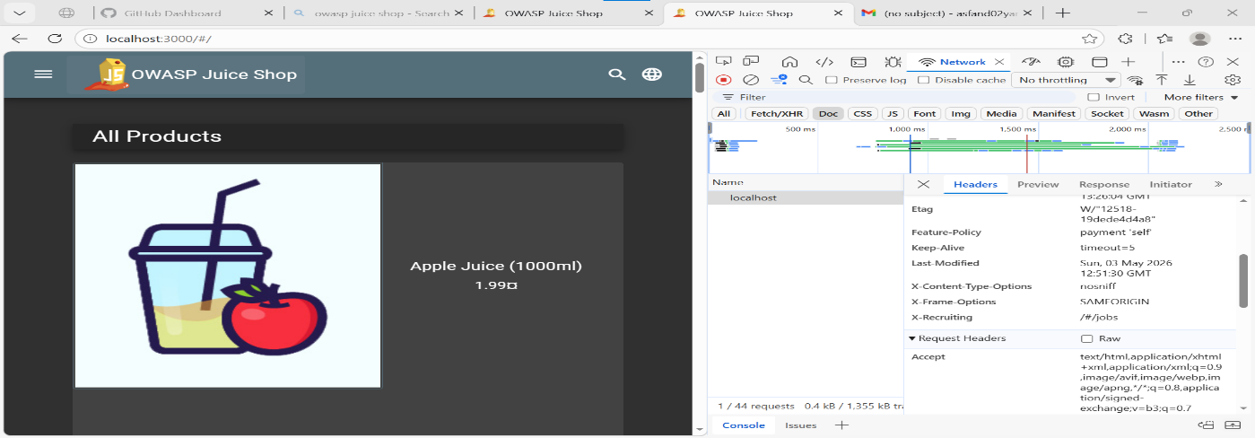
Result: Successfully Mitigated
Vulnerability 2: Components with Known Vulnerabilities
Description:
A dependency scan was performed using npm audit on the Juice Shop codebase. The scan identified 62 total vulnerabilities: 6 Low, 18 Moderate, 31 High, and 7 Critical.
Risk Level: Critical
CWE: CWE-1104: Use of Unmaintained Third Party Components
Key Vulnerabilities Identified:
1. vm2 package - Critical: Multiple Sandbox Escape vulnerabilities (CVE-2023-32314) allowing for Remote Code Execution on the server.
2. ws package - High: Vulnerable to Denial of Service attacks.
Remediation Attempt:
An attempt was made to automatically patch vulnerabilities using the npm audit fix command.
Verification:
Before Fix: npm audit output showed 62 vulnerabilities.
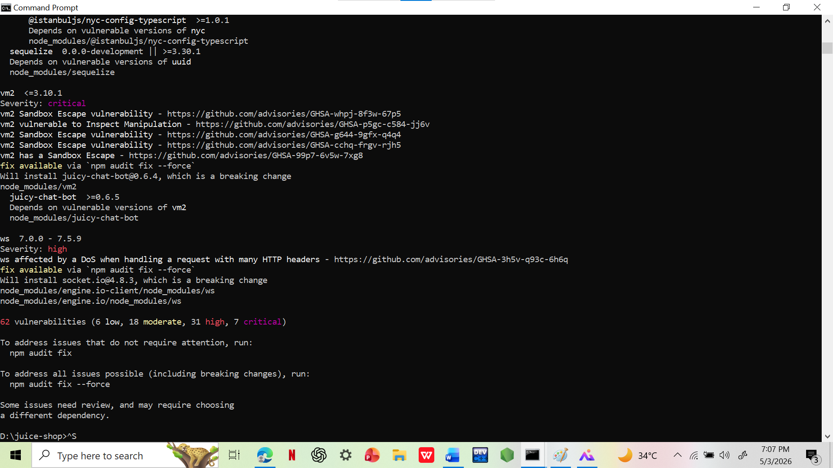
After Fix Attempt: The npm audit fix command failed due to major version conflicts in legacy dependencies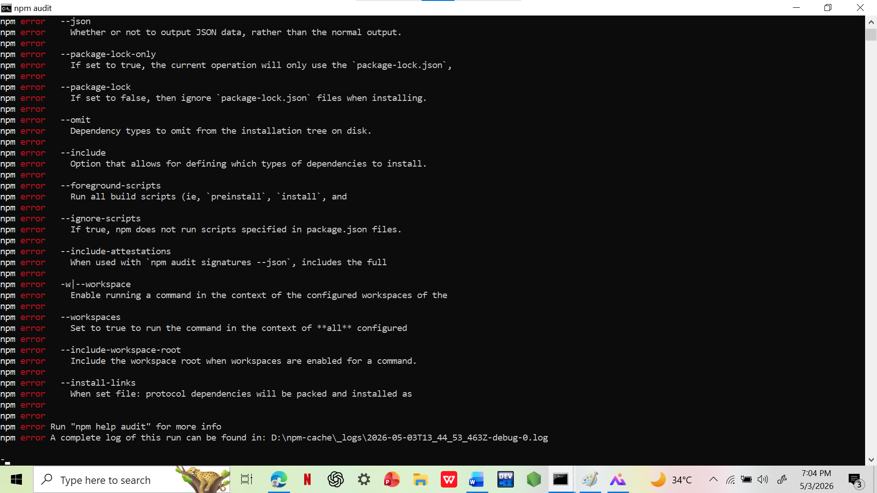

Result: Failed to Remediate
The failure of the automated fix demonstrates a significant security risk known as "security debt." The application's dependencies are so outdated that security patches cannot be applied without causing breaking changes. This leaves the application exposed to known critical exploits.
Recommendation:
For a production environment, it is recommended to either migrate to actively maintained, secure versions of the affected packages or replace them with alternative libraries. Relying on automated tools is insufficient for legacy applications.

